Final Project Proposal: Studify – A Study Planner & Academic Resource App
1. Overview
Studify is a web application designed to help students stay organized, motivated, and engaged in their learning. It solves common study challenges such as procrastination, poor time management, and difficulty finding quick practice resources. Users can plan study sessions, generate custom trivia quizzes, and get daily motivational quotes to stay productive.
Motivation: As a student, I often struggle with consistent study habits. Studify combines structured planning with interactive tools that keep learning engaging and enjoyable.

2. Target Audience
- Primary: High school and college students (ages 16–25) looking to organize their study schedules better.
- Secondary: Lifelong learners or exam-preparation candidates.
The app is ideal for anyone seeking a simple, free academic productivity tool.

3. Major Functions
- User Dashboard – Shows upcoming sessions, quick actions, and a daily motivational quote.
- Study Schedule Planner – Add, edit, and delete study sessions with title, date, subject, and duration.
- Quiz Generator – Fetch random questions from a wide range of categories (via OpenTDB).
- Quiz Score Summary – Score display, retry options, and optional local score saving.
- Motivational Quote Generator – Daily quotes fetched via ZenQuotes API.
- Quiz Category Browser – Browse and filter available quiz categories.
- Search Function – Search sessions or quiz categories.
- Responsive Navigation – Mobile-friendly nav bar for Dashboard, Planner, Quizzes, and Quotes.
- Progress Overview – Track completed vs. upcoming sessions (simple visualization).
- Export/Import Sessions – Export study schedule as JSON and restore it anytime.

4. Wireframes
Emmanuel Nasir
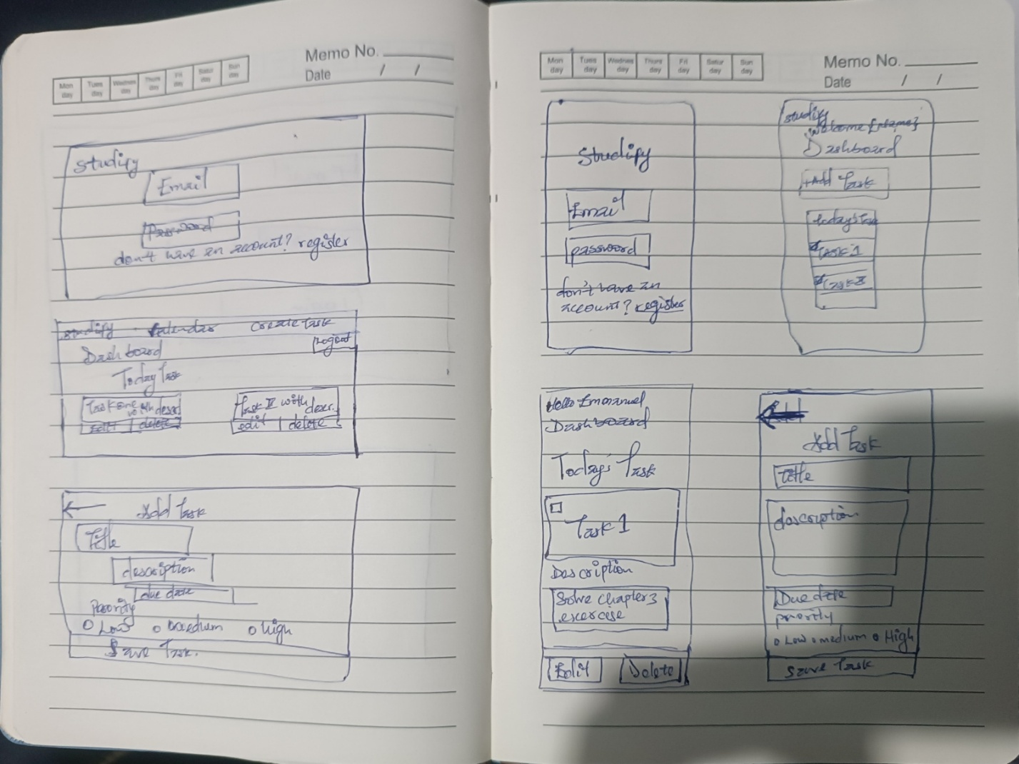

5. External Data
Purpose | API | What it provides
Quizzes | Open Trivia Database (OpenTDB) | Categories, difficulty settings, trivia questions
Quotes | ZenQuotes API | Motivational/educational quotes
Stored Data: Study sessions, quiz scores (localStorage), user preferences.

6. Module List
- API Module – Fetches trivia questions and quotes.
- Planner Module – Handles CRUD for study sessions.
- Quiz Module – Renders questions, checks answers, tracks score.
- Storage Module – Manages localStorage saving/loading.
- UI Components Module – Cards, forms, buttons, etc.
- Main App Module – Routing, state management.
- Utilities – Date/time formatting helpers.

7. Graphic Identity
- Colors:
  - Primary Blue: #4A90E2
  - Accent Green: #50C878
  - Background Gray: #F5F7FA
  - Text: #333
- Typography:
  - Headings: Poppins / Roboto Bold
  - Body: Roboto Regular
- Style: Rounded corners, soft shadows, clean modern layout.
- Icon: Open book + lightbulb (blue/green gradient).

8. Timeline
Week 5:
- Project setup
- API integration (quotes + basic quiz)
- Dashboard UI prototype
Week 6:
- Full planner CRUD
- Quiz scoring + categories
- LocalStorage persistence
Week 7:
- UI polishing, mobile optimization
- Progress tracking
- Final testing + deployment

9. Project Planning
Your Trello board should include lists:
- Backlog
- To Do
- In Progress
- Testing
- Done
With labels: API, UI, Planner, Quiz, Storage.

10. Challenges
- Handling API limits/errors
- Keeping quizzes engaging
- Ensuring smooth mobile responsiveness
- Preventing clutter and staying within scope

